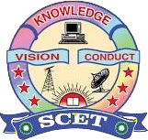 | SWARNANDHRA COLLEGE OF ENGINEERING AND TECHNOLOGY  (Autonomous)  Seetharamapuram, Narsapur. W.G.Dt – 534280  Approved by AICTE, Affiliated to JNTU(K)-Kakinada  Accredited by NBA(Tier-I) & NAAC with Grade “A”  DEPARTMENT OF ELECTRICAL & ELECTRONICS ENGINEERING

REPORT ON “PLC” by Falcon IT Training and Educational Services”

Event Type : A Three Days Workshop offline
Date / Duration : 28-08-2026 to 31-08-2026

Names of Coordinators : Mr. I Murali Krishna
Resource Person Name : Mr. Bhargav APOOR, Sr. Technical trainer
Target Audience : All EEE III EEE Students
Total no of Participants : 65

Objective of the event : “To provide participants with hands-on knowledge of PLC architecture, programming, input/output interfacing, industrial automation, and troubleshooting, enabling them to design and implement basic PLC-based control applications.
Outcome of event : Participants were able to understand,
program, and apply PLCs for basic industrial automation and control applications through hands-on practical training.

Description / Report on Event: A PLC Workshop was organized to provide students with practical knowledge of Programmable Logic Controllers and industrial automation. The workshop covered PLC basics, hardware components, Ladder Logic programming, input/output interfacing, timers, counters, and motor control. Hands-on demonstrations helped students understand real-time PLC applications and basic troubleshooting. The event enhanced students' practical skills and knowledge of industrial automation and control systems.

Dr. Satyanarayana Addala
Event Coordinators HoD/Dept of EEE

Day -1

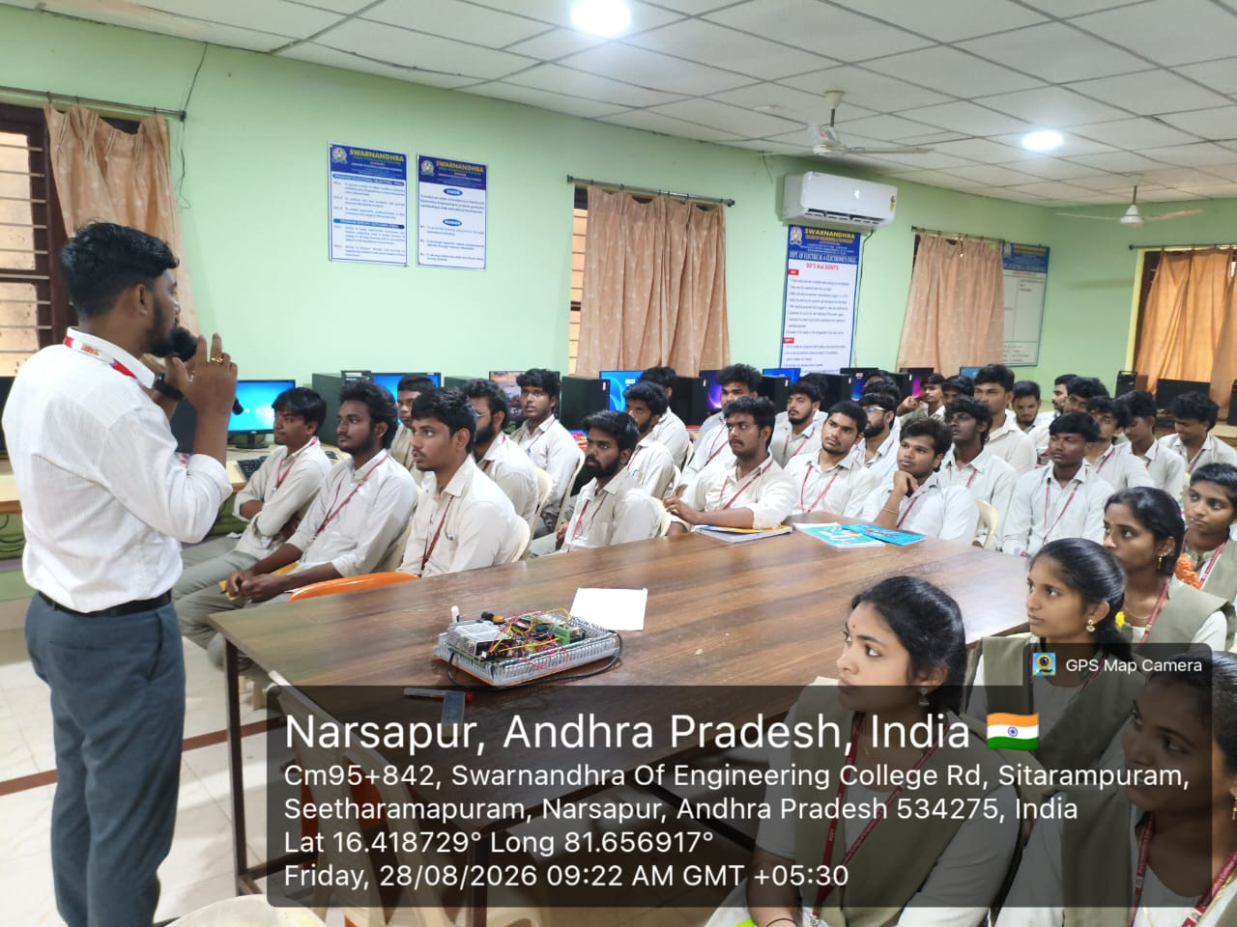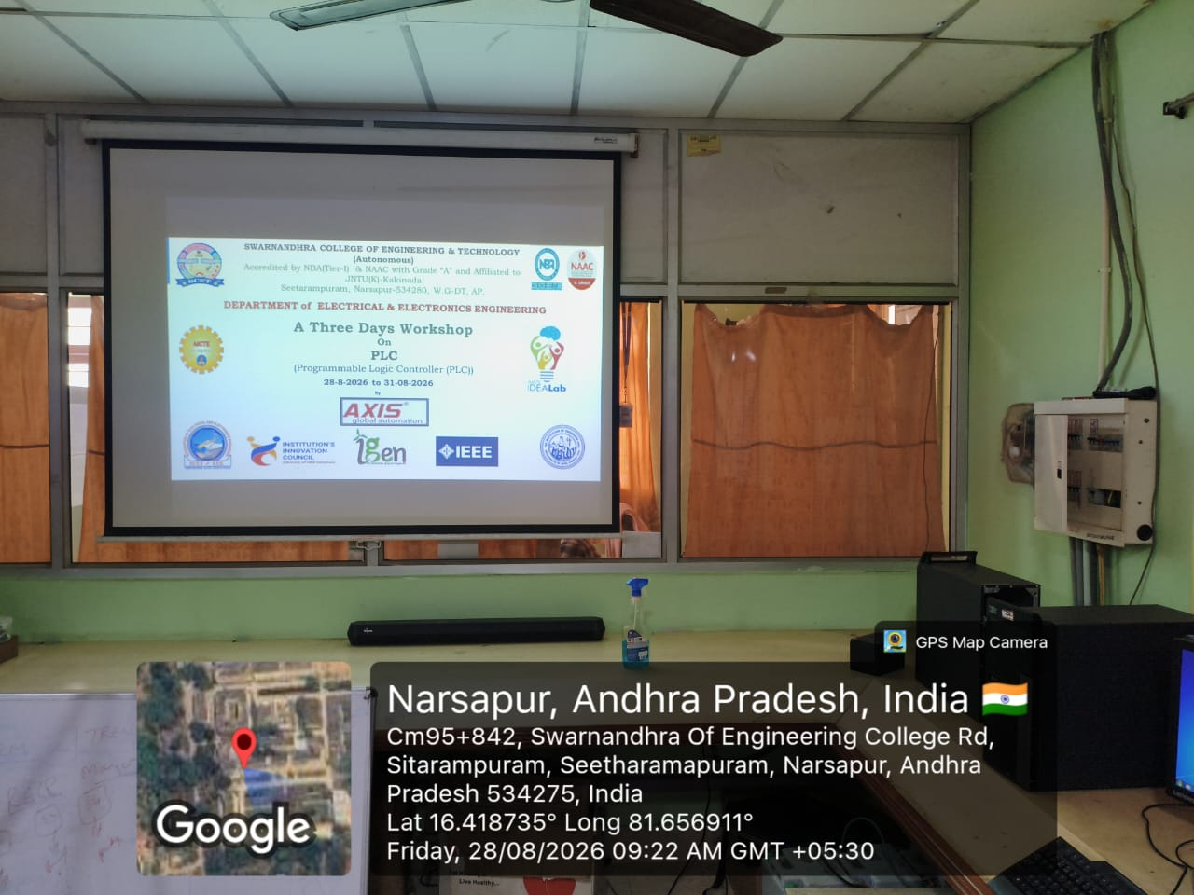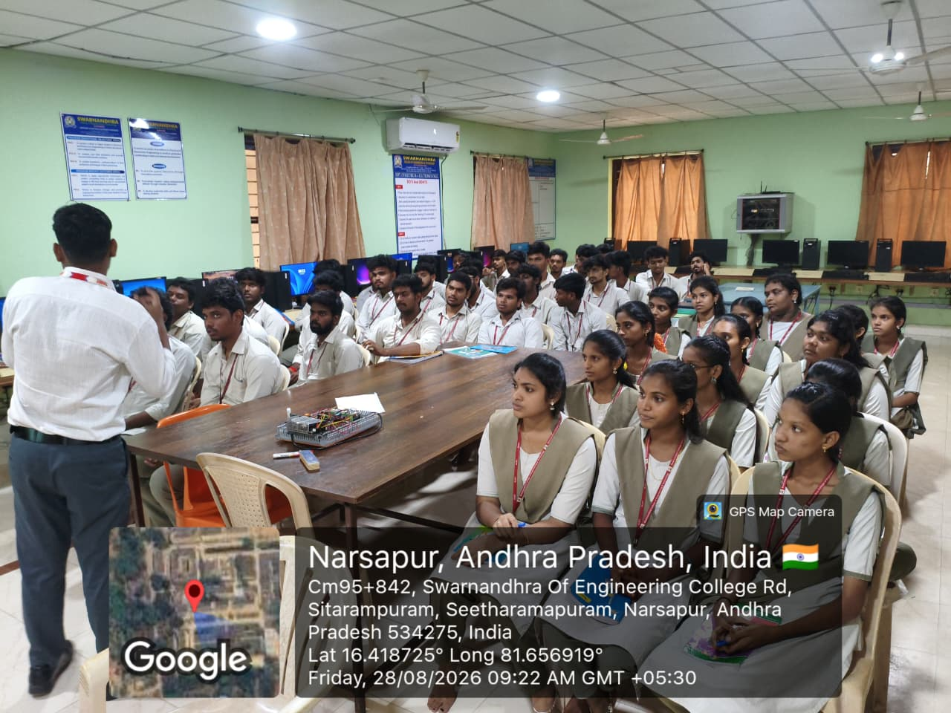

Day 2

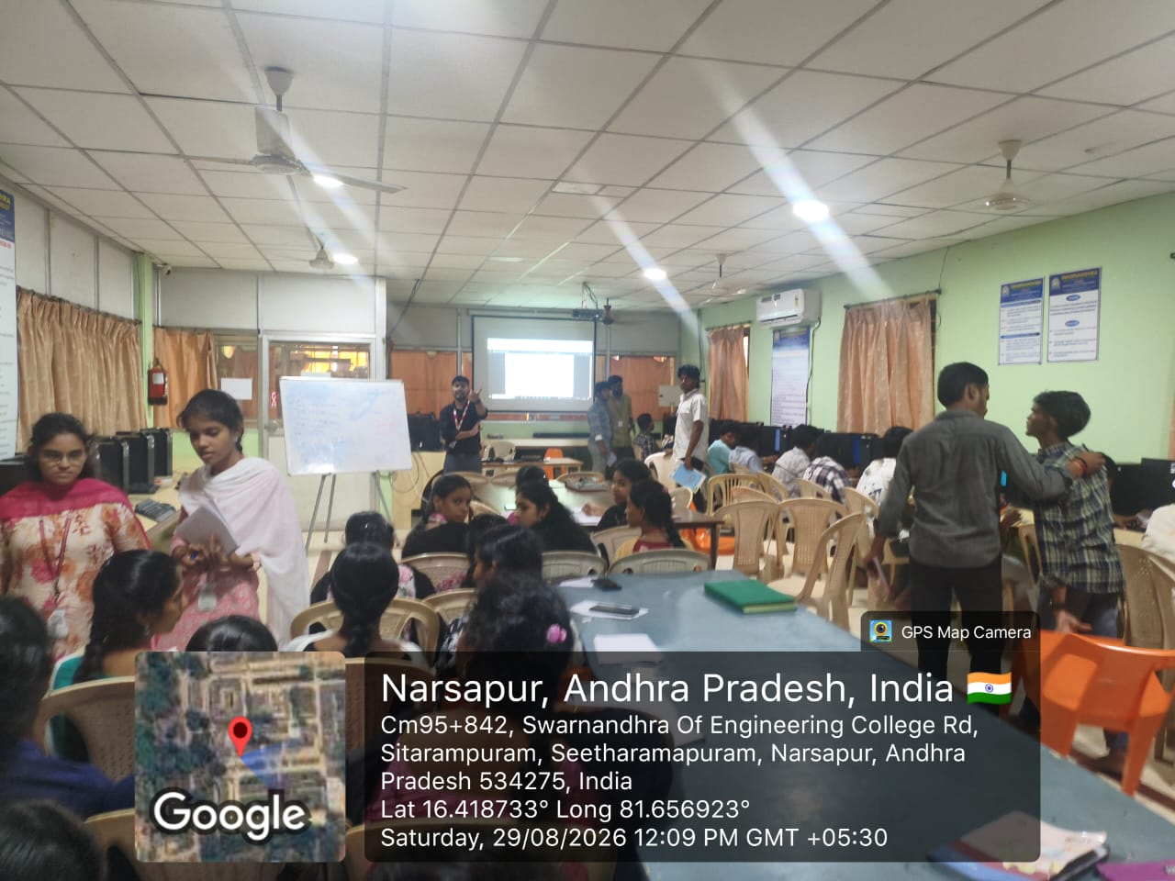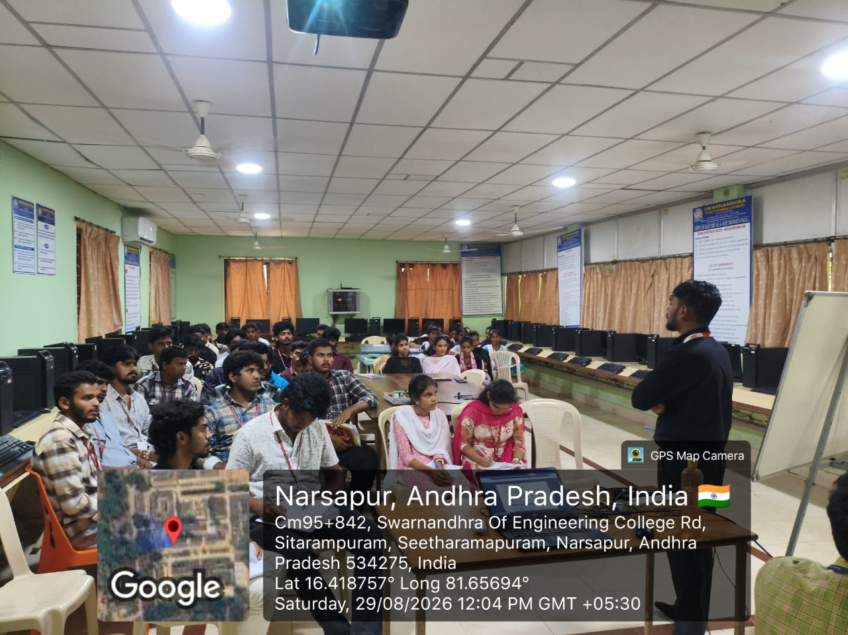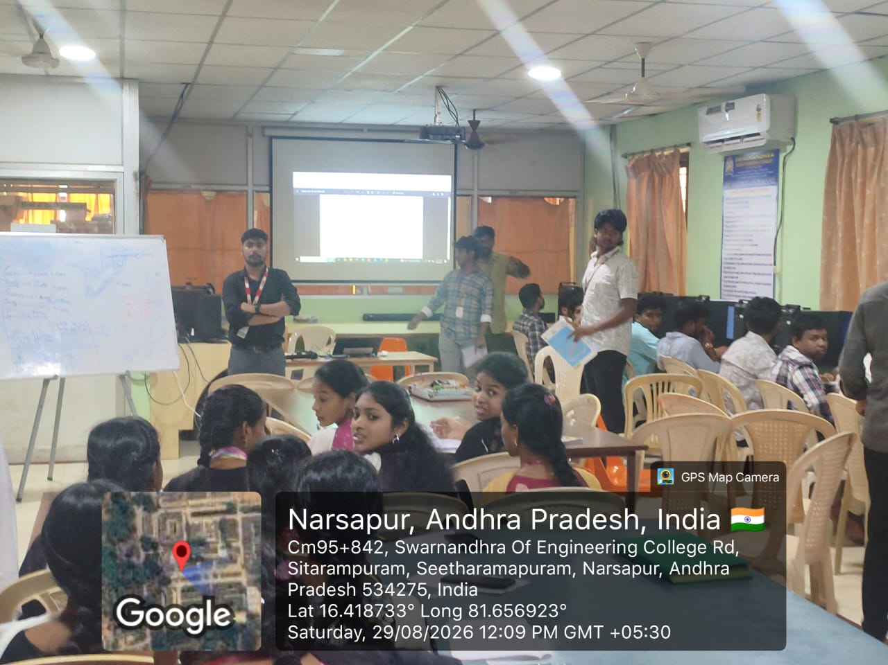

Day-3